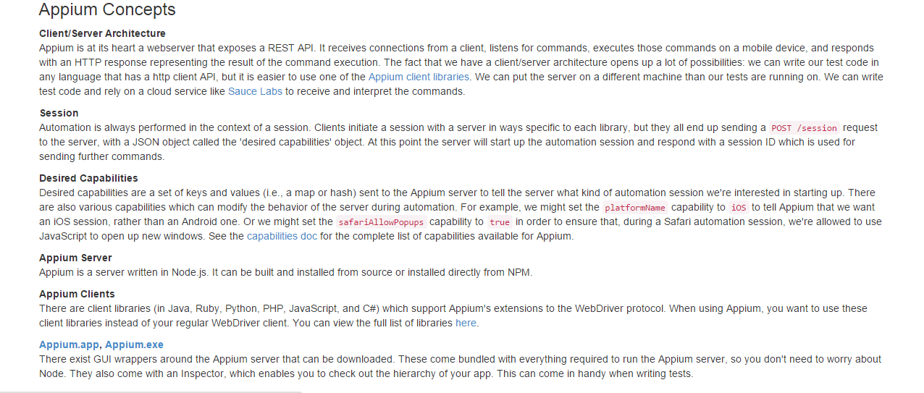

**Installation:**

* **Download Android Studio**